Cross-Asset Quantitative Finance
Markets, Relationships & Relative Value
A Level 2 module in the Quantitative Finance Curriculum (revisited at Level 5)
Covers: Equities · Fixed Income · FX · Commodities · Credit · Rates · Digital Assets · Cross-asset correlations · Relative value · Basis · Carry · Spreads · Yield curves · FX forwards · Futures · Intermarket relationships · Macro factors · Cross-asset hedging · Diversification · Regime dependence · Contagion · Cross-asset arbitrage

Table of Contents
How to Use This Guide 3
What You Need to Know Before Starting 3
Why It Matters 3
How This Connects to the Rest of the Curriculum 3
Glossary of Recurring Terms 4
Part 1 — Measuring and Interpreting Cross-Asset Relationships 5
1.1 Correlation, Covariance and Rolling Estimation 5
1.2 Beta and Common Risk Factors 5
1.3 Regime Dependence and Correlation Breakdown 6
1.4 Cross-Asset Data Conventions 6
Part 2 — Carry, Basis and Cross-Asset Relative Value 8
2.1 Carry and Roll Yield Across Asset Classes 8
2.2 Basis: Cash-Futures, Cross-Currency and Credit 9
2.3 Constructing and Evaluating a Cross-Asset Relative-Value Trade 9
2.4 Cross-Asset Hedging, Diversification and Contagion 10
Practical Exercise 11
Common Beginner Mistakes 12
Advanced Extensions 13
Professional Applications 14
Where to Go Next 15

How to Use This Guide

What You Need to Know Before Starting
This module assumes comfort with the following foundational areas. Each connects directly to the cross-asset material that follows:
- Returns & Portfolio Mathematics — log vs. simple returns, portfolio variance and covariance are the building blocks of every cross-asset correlation and beta calculation in this module.
- Statistics — correlation, covariance, rolling windows and z-scores are used throughout; you should be comfortable interpreting a standard deviation and a confidence interval.
- Risk Metrics — volatility, drawdown and value-at-risk concepts recur when evaluating cross-asset hedges and relative-value trades.
- Derivatives — Core Pricing — futures, forwards and basic swap mechanics underpin the carry and basis discussion in Part 2.
- Optimisation — constructing a relative-value trade or a hedged portfolio is an optimisation problem under constraints.
- Time-Series Analysis — rolling statistics, stationarity and mean reversion are central to how spreads and correlations are measured and traded.
Tip: If any of the above feels shaky, it is worth revisiting before continuing — cross-asset work is where gaps in these foundations tend to surface first, because a mistake in one market's return convention silently corrupts every relationship you compute against it.

Why It Matters
Financial markets do not operate independently. Movements in rates, currencies, commodities, equities, credit and digital assets can interact through common risk factors, funding conditions, macroeconomic expectations and investor positioning. A rate shock can move currencies, which moves commodity prices denominated in that currency, which moves the equities of commodity producers, which moves the credit spreads of those same issuers. Understanding these relationships — and knowing when they break down — is essential for analysing portfolios and strategies that span multiple markets, and for avoiding the false comfort of diversification that was never as stable as it looked.

How This Connects to the Rest of the Curriculum
- Connects to Research: cross-asset research provides the foundation for relative-value strategies, macro signals, pairs and spread trading, cross-market arbitrage, regime analysis and multi-asset portfolio construction.
- Connects to Development: cross-asset systems require consistent data conventions across instruments and markets — including timestamps, currencies, trading calendars, contract specifications, roll adjustments, corporate actions and price transformations. Data alignment and instrument mapping are often as important as the modelling itself.
- Connects to Trading: cross-asset relationships are used for hedging, relative-value trading, basis trading, macro positioning, liquidity management and identifying pricing discrepancies between related instruments or markets.

Glossary of Recurring Terms
- Cross-asset correlation: The degree to which returns in one asset class move together with returns in another, typically measured over a rolling historical window.
- Beta: The sensitivity of an asset's returns to a reference factor or benchmark, estimated as the covariance with the factor divided by the factor's variance.
- Regime: A period during which the statistical relationships between assets — correlation, volatility, carry — behave in a broadly consistent way, before shifting to a different pattern.
- Correlation breakdown / regime dependence: The tendency for historical correlations to change, weaken or reverse sign when the underlying market regime changes, often at the worst possible time for a diversified portfolio.
- Common risk factor: An underlying driver — such as real rates, growth expectations or risk appetite — that simultaneously influences several asset classes, producing correlation between them without any direct causal link.
- Carry: The return an investor earns from holding a position if prices do not change, arising from interest-rate differentials, dividend yields, convenience yields or credit spreads.
- Roll yield: The gain or loss from rolling a futures position from an expiring contract into a later-dated one, driven by the shape of the futures curve.
- Basis: The difference between the price of a derivative (or related instrument) and the price of the underlying cash instrument — for example, futures price minus spot price.
- Spread: The price or yield difference between two related instruments, used both as a measure of relative value and as the object of a relative-value trade.
- Relative value: A trading approach that expresses a view on the price relationship between two or more related instruments, rather than on the direction of either instrument alone.
- Cross-asset arbitrage: A trade that seeks to exploit a pricing discrepancy between related instruments in different asset classes, after accounting for costs, funding and risk.
- Diversification: The reduction in portfolio risk achieved by combining assets whose returns are not perfectly correlated — valuable in calm regimes, and unreliable in stressed ones.
- Contagion: The spread of a price shock or liquidity stress from one market or asset class into others, typically through common holders, funding channels or forced deleveraging.
- Covered interest rate parity: The no-arbitrage relationship linking spot and forward FX rates to the interest-rate differential between two currencies.

Part 1 — Measuring and Interpreting Cross-Asset Relationships
Before any relative-value trade or hedge can be constructed, the relationships between assets need to be measured carefully — and their limitations understood. This part covers how correlation and beta are estimated in practice, why those estimates are regime-dependent, and the data conventions that make cross-asset comparisons valid in the first place.

1.1 Correlation, Covariance and Rolling Estimation
The starting point for any cross-asset analysis is the pairwise correlation between return series. For two assets with returns r₁ and r₂ over a window of n observations, the sample correlation is:
$$ρ\left(r_{1} , r_{2}\right)=\frac{Cov⁡\left(r_{1} , r_{2}\right)}{σ\left(r_{1}\right) σ\left(r_{2}\right)}$$
$$where Cov⁡\left(r_{1} , r_{2}\right)=\frac{1}{n-1}\sum_{t=1}^{n}{\left(r_{1,t}-{\overline{r}}_{1}\right)}\left(r_{2,t}-{\overline{r}}_{2}\right)$$
Because this relationship is rarely stable, it is almost always computed on a rolling basis — for example, a 60-day or 90-day trailing window — so that changes in the relationship become visible over time rather than being averaged away.
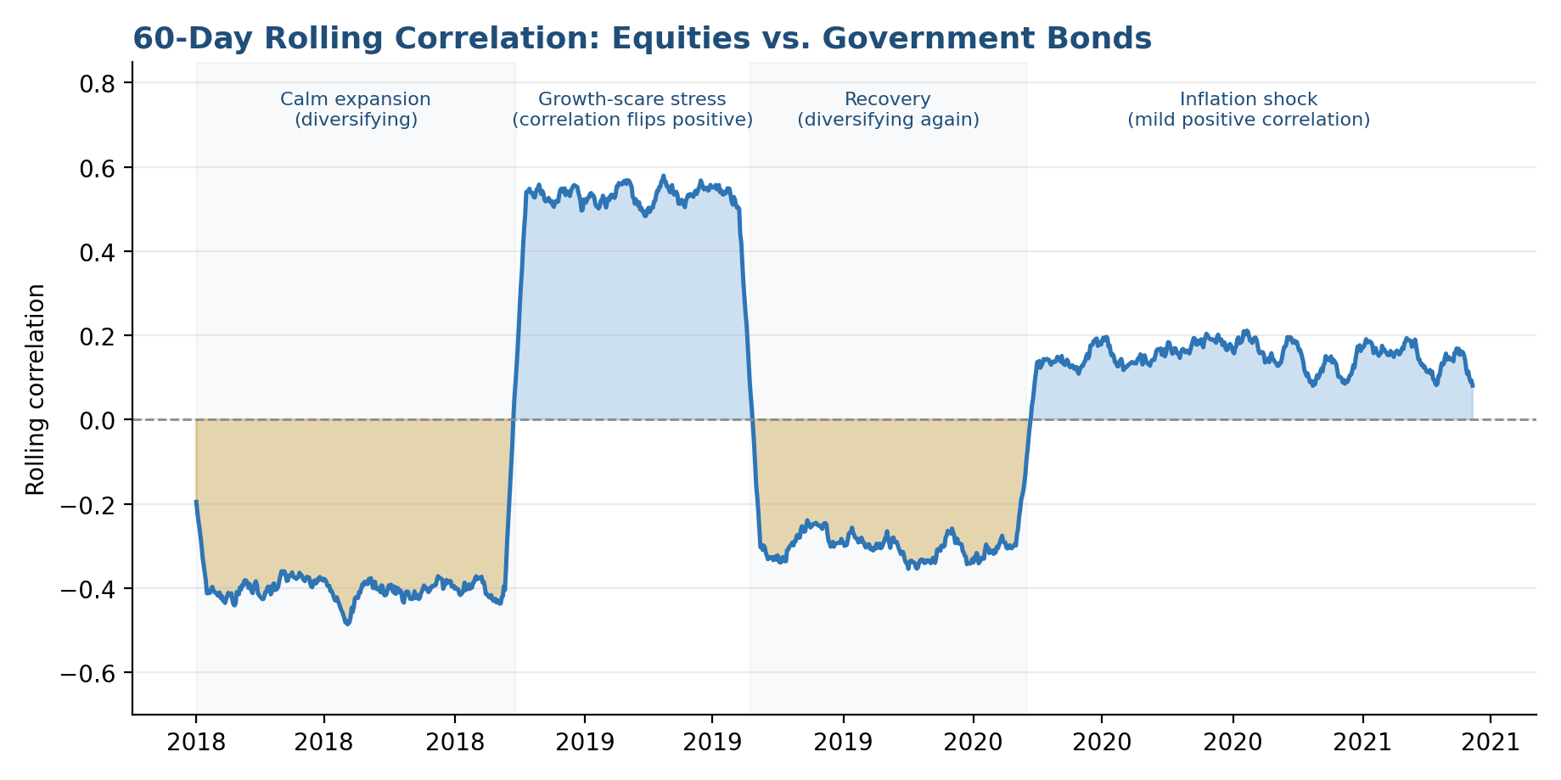
Figure 1.1. A 60-day rolling correlation between equities and government bonds. The relationship is not a fixed constant: it drifts negative in calm expansions, turns sharply positive during growth-scare stress, and settles at a mild positive level during an inflation shock.
Tip: Always report the window length alongside a rolling correlation figure. A 20-day window and a 250-day window of the same two assets can tell almost opposite stories.

1.2 Beta and Common Risk Factors
Beta extends the same idea to describe an asset's sensitivity to a single reference factor — a benchmark equity index, a rates factor, or a broad risk-appetite proxy:

$$β_{\text{asset},\text{factor}}=\frac{Cov⁡\left(r_{\text{asset}} , r_{\text{factor}}\right)}{Var⁡\left(r_{\text{factor}}\right)}$$
Many apparent cross-asset correlations are not direct relationships at all, but the shared exposure of two assets to the same underlying factor — real interest rates, growth expectations or investor risk appetite. A commodity currency and a commodity-producer's equity may correlate closely not because one drives the other, but because both load heavily on the same commodity-price factor.

1.3 Regime Dependence and Correlation Breakdown
Correlation matrices are frequently presented as if they were fixed properties of the market. In practice they are regime-dependent: the relationship between two assets in a low-volatility, low-inflation environment can look nothing like the relationship during a liquidity crisis or an inflation shock.
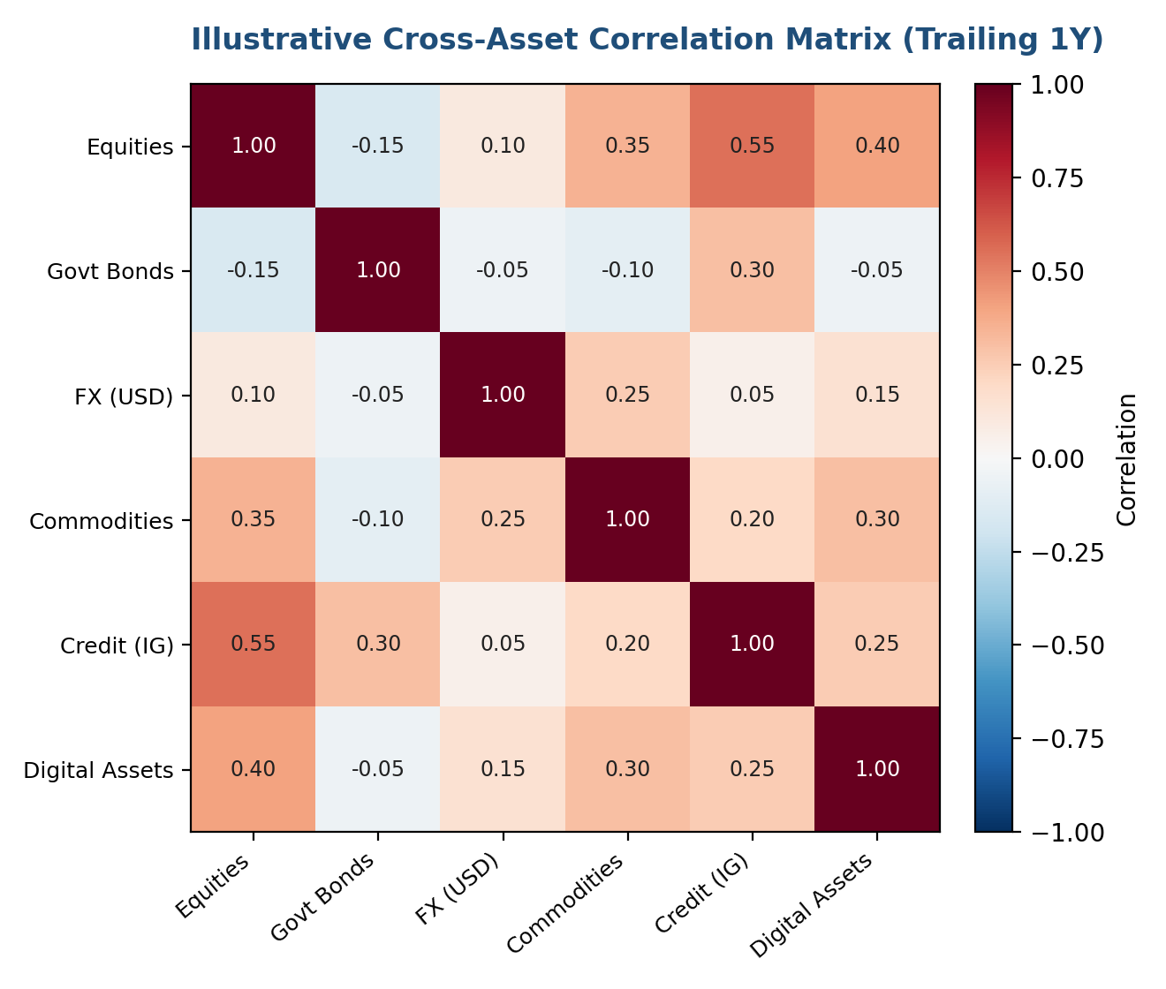
Figure 1.2. An illustrative trailing one-year correlation matrix across six asset classes. Matrices like this are a snapshot of one regime, not a permanent map of how these markets relate to one another.
Common mistake: Treating a correlation matrix estimated over a calm period as a reliable guide to how a portfolio will behave in a stressed one. Diversification benefits measured in normal markets frequently shrink — or disappear — exactly when a portfolio needs them most.

1.4 Cross-Asset Data Conventions
Cross-asset systems require consistent data conventions across instruments and markets. Comparing two return series that differ in timestamp convention, trading calendar or contract specification produces a correlation number that looks precise but measures nothing real.
Convention | Why it matters | Common pitfall
Timestamps & time zones | Markets close at different local times; naive daily alignment can mismatch which day's move is being compared. | Comparing a US equity close to an Asian FX close from a different calendar day.
Trading calendars | Not all markets are open on the same days; holidays differ by country and asset class. | Filling a holiday gap with a stale price, creating an artificial zero return.
Contract specifications | Futures contracts differ in multiplier, tick size and quotation currency across exchanges. | Comparing raw price changes across contracts without adjusting for contract size.
Roll adjustments | Futures series must be spliced across expiries; unadjusted series show artificial jumps at roll dates. | Treating a roll-driven price jump as a genuine market move.
Corporate actions | Equity prices must be adjusted for dividends, splits and other actions to give a true return. | Computing an equity return series from unadjusted close prices.
Price transformations | Levels, log returns and simple returns are not interchangeable inputs to correlation or beta. | Mixing return conventions across the two series being compared.

Part 2 — Carry, Basis and Cross-Asset Relative Value
Once relationships between assets are understood, the next question is how to express a view on them. This part covers carry and basis — the return and pricing gaps that exist even when nothing else changes — and how they are combined into a relative-value trade, a hedge, or a diversified allocation.

2.1 Carry and Roll Yield Across Asset Classes
Carry is the return earned from holding a position if prices do not move at all. Its source differs by asset class, but the underlying idea — compensation for holding risk, funding or storage over time — is common across markets.
Asset class | Source of carry | Typical driver
FX | Interest-rate differential between the two currencies | Higher-yielding currency earns positive carry versus the funding currency
Government bonds | Term premium and roll-down along the yield curve | Curve slope and expected path of policy rates
Commodities | Convenience yield versus storage and financing cost | Backwardation (positive carry) or contango (negative carry)
Equities | Dividend yield net of financing/borrow cost | Index dividend yield relative to short-term funding rates
Credit | Spread over the risk-free rate for bearing default risk | Credit spread level and shape of the credit curve
Digital assets | Funding-rate differentials in perpetual futures markets | Positioning imbalance between longs and shorts
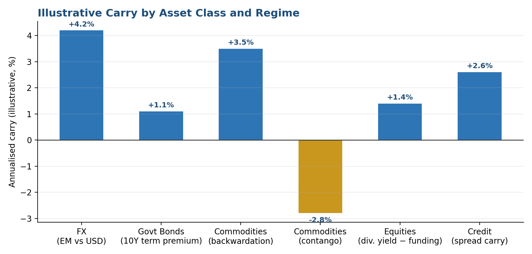
Figure 2.1. Illustrative annualised carry across asset classes and regimes. Carry can be positive or negative, and its sign can flip — commodity carry, for example, depends entirely on whether the futures curve is in backwardation or contango.

2.2 Basis: Cash-Futures, Cross-Currency and Credit
Basis measures the gap between the price of a derivative or related instrument and its underlying cash instrument. The simplest form is the futures basis:
Basis = Futures price − Spot price
In FX, covered interest rate parity links the forward rate to the spot rate and the interest-rate differential between two currencies:
$$F=S×\frac{1+r_{\text{domestic}}}{1+r_{\text{foreign}}}$$
A persistent deviation from this relationship is the cross-currency basis, which reflects funding pressure and demand for a given currency outside its home market rather than a pure arbitrage opportunity. A similar logic applies to the CDS-bond basis in credit markets, where the CDS-implied spread and the cash-bond spread can diverge for reasons tied to funding, liquidity and contract technicalities rather than mispricing alone.
Tip: A non-zero basis is not automatically an arbitrage. It usually compensates someone for funding, liquidity or balance-sheet constraints — the question is always whether that compensation exceeds the cost of holding the trade.

2.3 Constructing and Evaluating a Cross-Asset Relative-Value Trade
A relative-value trade expresses a view that the relationship between two instruments — not the direction of either one — will move back toward a historical or fair-value level. The spread is typically standardised into a z-score:
$$z_{t}=\frac{{spread}_{t}-μ_{spread}}{σ_{spread}}$$
Entry and exit rules are then defined relative to that z-score — for example, entering short the spread when it exceeds +2 standard deviations, and long the spread when it falls below −2, with an exit closer to the mean.
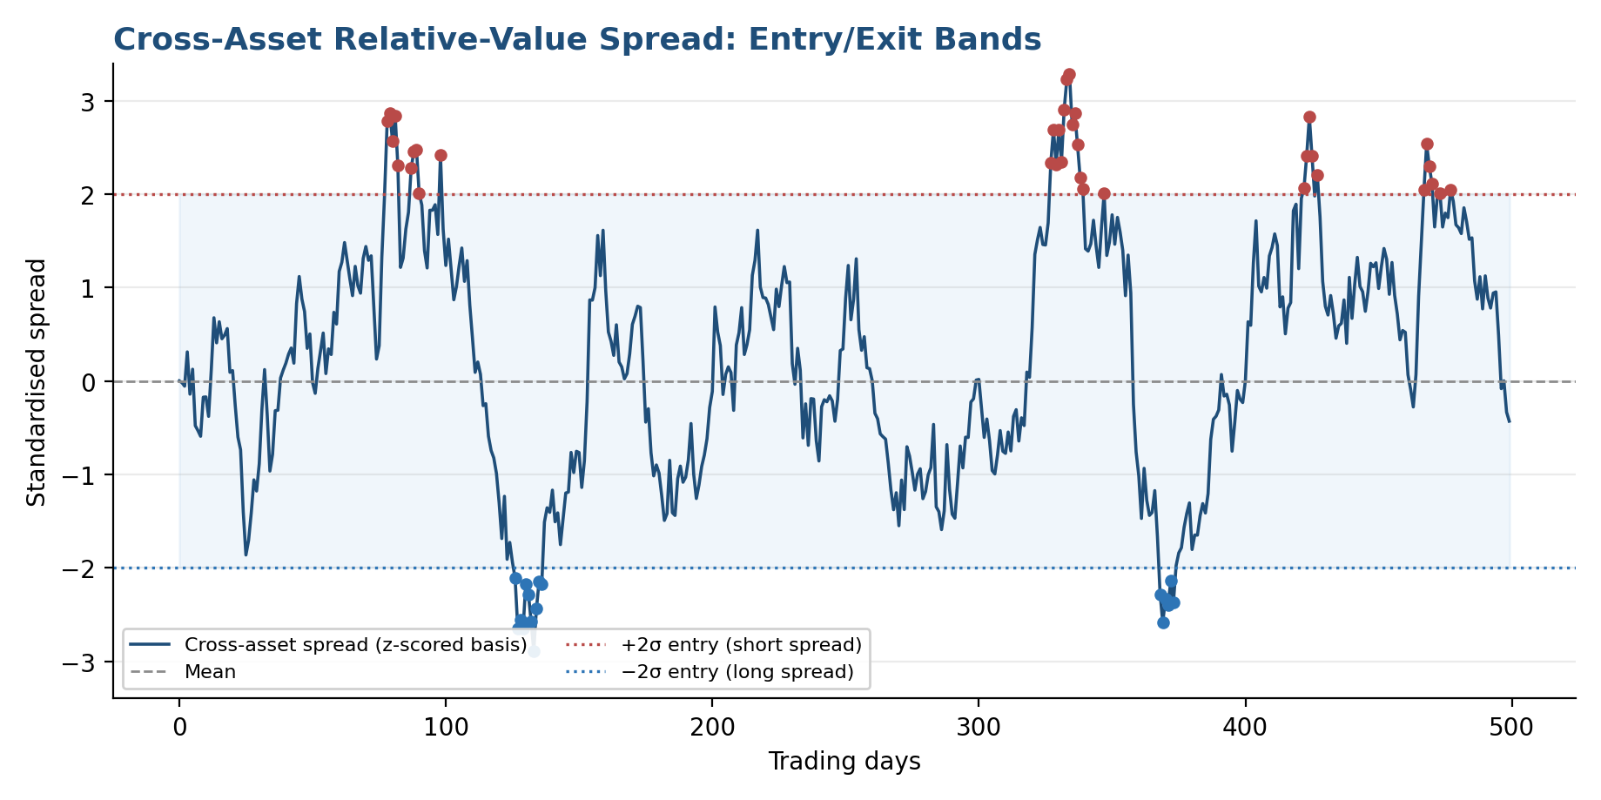
Figure 2.2. A standardised cross-asset spread oscillating around its mean, with ±2σ entry bands. The spread repeatedly reaches the bands and reverts — but a real trade must also survive the periods where it does not.
for each date t in backtest:
spread[t] = price_A[t] - hedge_ratio * price_B[t]
z[t] = (spread[t] - rolling_mean) / rolling_std
if z[t] > entry_threshold and no_position:
enter_short_spread()
elif z[t] < -entry_threshold and no_position:
enter_long_spread()
elif abs(z[t]) < exit_threshold and in_position:
close_position()
apply_transaction_costs_and_funding()
Common mistake: Treating a statistical relationship as an arbitrage opportunity without considering transaction costs, funding, liquidity, execution and basis risk. A spread that looks attractive on mid-prices can be unprofitable once realistic costs and financing are included.

2.4 Cross-Asset Hedging, Diversification and Contagion
The same correlation and beta estimates used to find relative-value trades are also used defensively — to hedge one exposure with another, or to construct a portfolio that is diversified across regimes rather than just across labels. This is harder than it sounds: diversification measured in a calm regime can evaporate in a stressed one, and the same channels that link markets in normal times — common holders, shared funding, correlated positioning — become the channels through which contagion spreads a shock from one asset class into others.
Tip: A hedge or a diversified allocation should be stress-tested against the regime in which it is most likely to be needed, not only against the regime in which it was estimated.

Practical Exercise
Construct a multi-asset dataset containing equities, government bonds, FX, commodities and digital assets. Analyse rolling correlations, beta relationships, carry and basis, then construct a cross-asset relative-value trade and evaluate its performance, drawdown and behaviour across different market regimes.
- Step 1 — Assemble and align the data: collect daily prices for one instrument in each of equities, government bonds, FX, commodities and digital assets. Align timestamps, trading calendars and price transformations as described in Section 1.4 before computing anything.
- Step 2 — Compute rolling relationships: calculate rolling correlations and betas between each pair of assets over at least two window lengths, and identify periods where the relationship shifts materially.
- Step 3 — Estimate carry and basis: for each asset class, compute the relevant carry measure from Section 2.1, and where applicable a basis measure from Section 2.2.
- Step 4 — Construct a relative-value trade: select two related instruments, build a standardised spread, and define entry and exit rules based on its z-score.
- Step 5 — Evaluate performance and regime behaviour: backtest the trade including realistic transaction costs and funding, then break the results down by market regime to see whether performance, drawdown and correlation to the rest of the portfolio are stable or regime-dependent.
Tip: Report your relative-value trade's drawdown separately for calm and stressed regimes. A strategy that looks attractive unconditionally can be concentrating all of its risk in exactly the periods where the rest of the portfolio is also under pressure.

Common Beginner Mistakes
Mistake 1 — Treating historical correlations as permanent relationships. A correlation estimated over one sample period is a description of that period, not a law of the market. Relationships between asset classes shift as the dominant macro driver changes — what held during a growth-scare regime may reverse entirely during an inflation shock.
Mistake 2 — Comparing asset prices directly without accounting for differences in units, currencies, contract specifications and volatility. Equities, bonds, FX and commodities are quoted in different units, currencies and contract sizes, and carry very different volatility. Comparing raw price levels or unscaled changes produces relationships that are artifacts of these differences rather than genuine economic links.
Mistake 3 — Ignoring time-zone and market-hours differences when calculating cross-asset relationships. Markets in different regions close at different times. Naively aligning daily data by calendar date can pair a market's reaction to news with a return computed before that news was known, understating or distorting the true relationship.
Mistake 4 — Interpreting correlation as causation. Two assets can move together because one drives the other, because both are driven by a shared factor, or by coincidence over a limited sample. Assuming a causal story without evidence leads to relationships that fail exactly when they are relied upon.
Mistake 5 — Treating a statistical relationship as an arbitrage opportunity without considering transaction costs, funding, liquidity, execution and basis risk. A spread that appears attractive on historical mid-prices can be unprofitable once realistic trading costs, financing charges, execution slippage and the basis risk between the two legs are included.

Advanced Extensions
Beyond the estimation and trading approaches covered here, cross-asset quantitative finance extends in several directions. On the measurement side, dynamic conditional correlation models, copula models and regime-switching correlation frameworks aim to capture time-varying dependence more rigorously than a rolling-window estimate; factor models and cross-asset volatility modelling generalise the single-factor beta intuition of Section 1.2 into a fuller description of shared risk. On the trading side, statistical arbitrage and relative-value optimisation formalise the spread-trading approach of Section 2.3 into a portfolio problem across many pairs simultaneously, informed by macro factor modelling and term-structure models of the underlying curves. Finally, cross-asset contagion and systemic-risk modelling, together with multi-asset derivatives and structured products, sit at the more advanced end of the discipline and are revisited in full at Level 5.

Professional Applications
- Portfolio construction and allocation — multi-asset portfolio construction, asset allocation and hedging all depend on the correlation, beta and regime concepts developed in Part 1.
- Research and macro positioning — global macro research and relative-value trading use these relationships to identify opportunities across markets rather than within a single one.
- Trading and arbitrage — cross-asset arbitrage, derivatives trading, and FX, rates and commodities trading all rely on the carry and basis concepts developed in Part 2.
- Risk management — risk management functions use cross-asset correlation and contagion analysis to understand how a portfolio will behave when historical relationships break down.
- Digital assets — digital-asset trading increasingly applies the same relative-value and carry frameworks used in traditional cross-asset markets, adapted to that market's funding and liquidity structure.

Where to Go Next
This module has covered how to measure cross-asset relationships, how to price the carry and basis that exist between related instruments, and how to combine both into a relative-value trade or a hedge — while remaining alert to the fact that these relationships are regime-dependent and can break down without warning. Where you go next depends on which side of the work you are heading toward.
- For research: continue toward factor models, dynamic conditional correlation, copulas and regime-switching frameworks to formalise the regime-dependence discussed in Section 1.3.
- For development: focus on the data-alignment and instrument-mapping conventions in Section 1.4 — they are frequently the difference between a correct and an incorrect cross-asset system.
- For trading: build on Section 2.3 by extending a single relative-value pair into a broader statistical-arbitrage book, with explicit attention to transaction costs, funding and basis risk.
Tip: Whichever path you take, revisit this module at Level 5, where cross-asset contagion, systemic-risk modelling and multi-asset structured products build directly on the foundations covered here.

